**CÁC BƯỚC CÀI ĐẶT REACTIVE BEERS USING COUCHDB TRÊN**

**UBUNTU**

**Install Curl:**

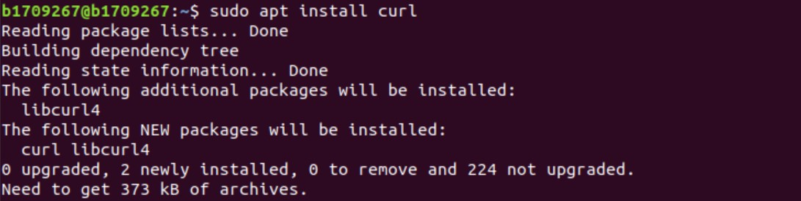

**I**

**n**

**s**

**t**

**a**

**l**

**l**

**N**

**o**

**d**

**e**

**j**

**s**

**:**

[**h**](https://github.com/nodesource/distributions/blob/master/README.md)

[**t**](https://github.com/nodesource/distributions/blob/master/README.md)

[**t**](https://github.com/nodesource/distributions/blob/master/README.md)

[**p**](https://github.com/nodesource/distributions/blob/master/README.md)

[**s**](https://github.com/nodesource/distributions/blob/master/README.md)

[**:**](https://github.com/nodesource/distributions/blob/master/README.md)

[**/**](https://github.com/nodesource/distributions/blob/master/README.md)

[**/**](https://github.com/nodesource/distributions/blob/master/README.md)

[**g**](https://github.com/nodesource/distributions/blob/master/README.md)

[**i**](https://github.com/nodesource/distributions/blob/master/README.md)

[**t**](https://github.com/nodesource/distributions/blob/master/README.md)

[**h**](https://github.com/nodesource/distributions/blob/master/README.md)

[**u**](https://github.com/nodesource/distributions/blob/master/README.md)

[**b**](https://github.com/nodesource/distributions/blob/master/README.md)

[**.**](https://github.com/nodesource/distributions/blob/master/README.md)

[**c**](https://github.com/nodesource/distributions/blob/master/README.md)

[**o**](https://github.com/nodesource/distributions/blob/master/README.md)

[**m**](https://github.com/nodesource/distributions/blob/master/README.md)

[**/**](https://github.com/nodesource/distributions/blob/master/README.md)

[**n**](https://github.com/nodesource/distributions/blob/master/README.md)

[**o**](https://github.com/nodesource/distributions/blob/master/README.md)

[**d**](https://github.com/nodesource/distributions/blob/master/README.md)

[**e**](https://github.com/nodesource/distributions/blob/master/README.md)

[**s**](https://github.com/nodesource/distributions/blob/master/README.md)

[**o**](https://github.com/nodesource/distributions/blob/master/README.md)

[**u**](https://github.com/nodesource/distributions/blob/master/README.md)

[**r**](https://github.com/nodesource/distributions/blob/master/README.md)

[**c**](https://github.com/nodesource/distributions/blob/master/README.md)

[**e**](https://github.com/nodesource/distributions/blob/master/README.md)

[**/**](https://github.com/nodesource/distributions/blob/master/README.md)

[**d**](https://github.com/nodesource/distributions/blob/master/README.md)

[**i**](https://github.com/nodesource/distributions/blob/master/README.md)

[**s**](https://github.com/nodesource/distributions/blob/master/README.md)

[**t**](https://github.com/nodesource/distributions/blob/master/README.md)

[**r**](https://github.com/nodesource/distributions/blob/master/README.md)

[**i**](https://github.com/nodesource/distributions/blob/master/README.md)

[**b**](https://github.com/nodesource/distributions/blob/master/README.md)

[**u**](https://github.com/nodesource/distributions/blob/master/README.md)

[**t**](https://github.com/nodesource/distributions/blob/master/README.md)

[**i**](https://github.com/nodesource/distributions/blob/master/README.md)

[**o**](https://github.com/nodesource/distributions/blob/master/README.md)

[**n**](https://github.com/nodesource/distributions/blob/master/README.md)

[**s**](https://github.com/nodesource/distributions/blob/master/README.md)

[**/**](https://github.com/nodesource/distributions/blob/master/README.md)

[**b**](https://github.com/nodesource/distributions/blob/master/README.md)

[**l**](https://github.com/nodesource/distributions/blob/master/README.md)

[**o**](https://github.com/nodesource/distributions/blob/master/README.md)

[**b**](https://github.com/nodesource/distributions/blob/master/README.md)

[**/**](https://github.com/nodesource/distributions/blob/master/README.md)

[**m**](https://github.com/nodesource/distributions/blob/master/README.md)

[**a**](https://github.com/nodesource/distributions/blob/master/README.md)

[**s**](https://github.com/nodesource/distributions/blob/master/README.md)

[**t**](https://github.com/nodesource/distributions/blob/master/README.md)

[**e**](https://github.com/nodesource/distributions/blob/master/README.md)

[**r**](https://github.com/nodesource/distributions/blob/master/README.md)

[**/**](https://github.com/nodesource/distributions/blob/master/README.md)

[**R**](https://github.com/nodesource/distributions/blob/master/README.md)

[**E**](https://github.com/nodesource/distributions/blob/master/README.md)

[**A**](https://github.com/nodesource/distributions/blob/master/README.md)

[**D**](https://github.com/nodesource/distributions/blob/master/README.md)

[**M**](https://github.com/nodesource/distributions/blob/master/README.md)

[**E**](https://github.com/nodesource/distributions/blob/master/README.md)

[**.**](https://github.com/nodesource/distributions/blob/master/README.md)

[**m**](https://github.com/nodesource/distributions/blob/master/README.md)

[**d**](https://github.com/nodesource/distributions/blob/master/README.md)

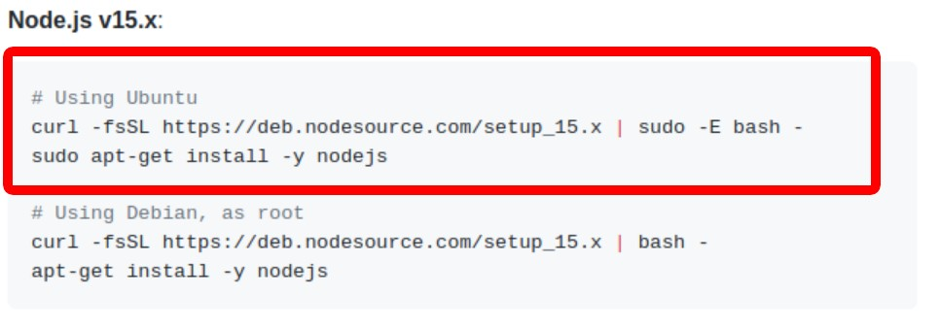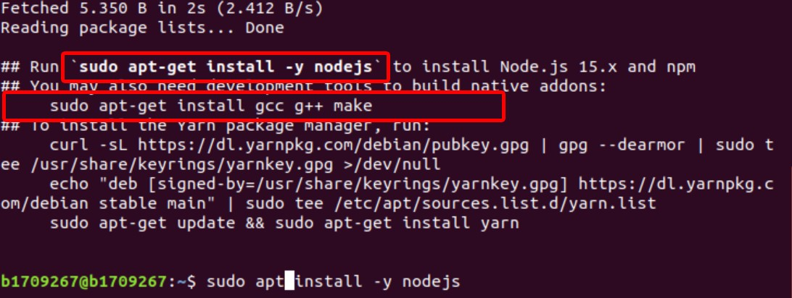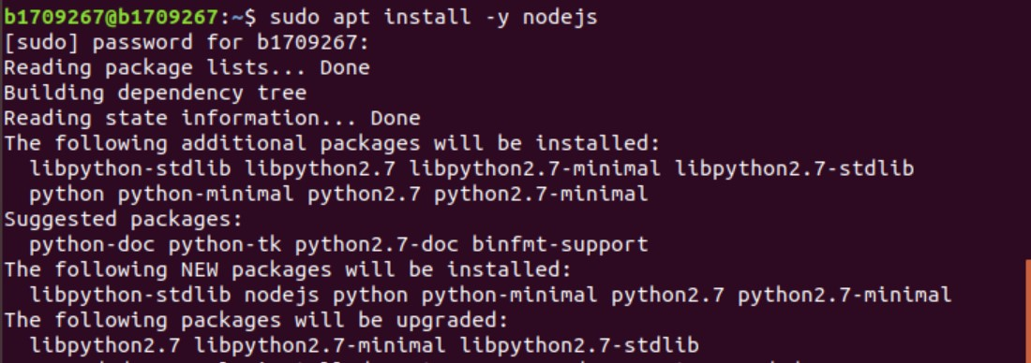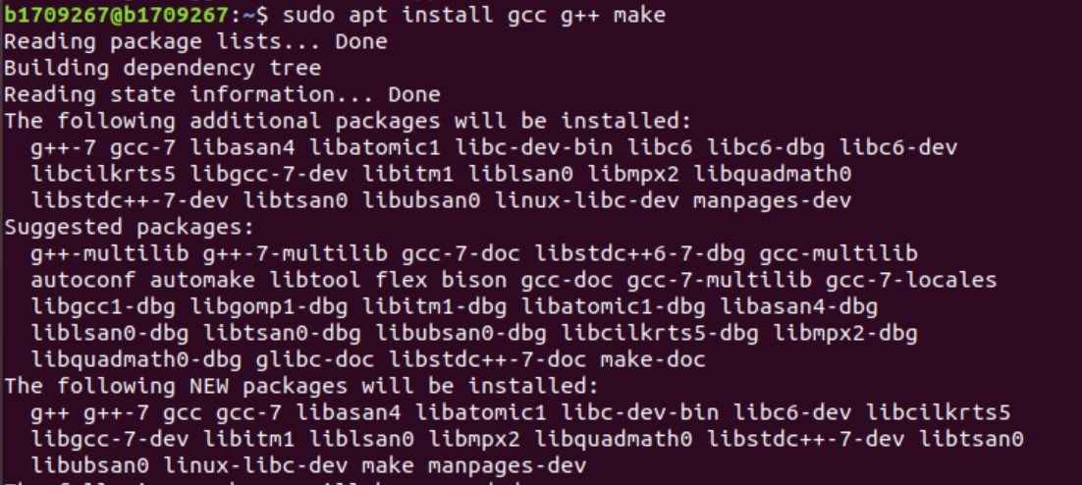

Cài đặt create-react-app:

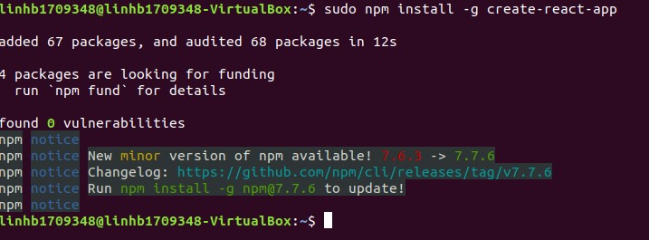

Update version 7.7.6:

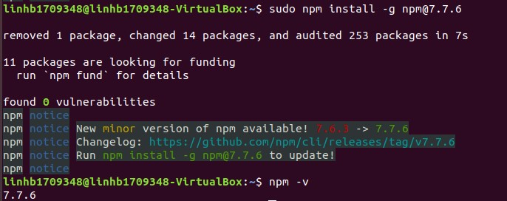

Create App Reactive-Beers:

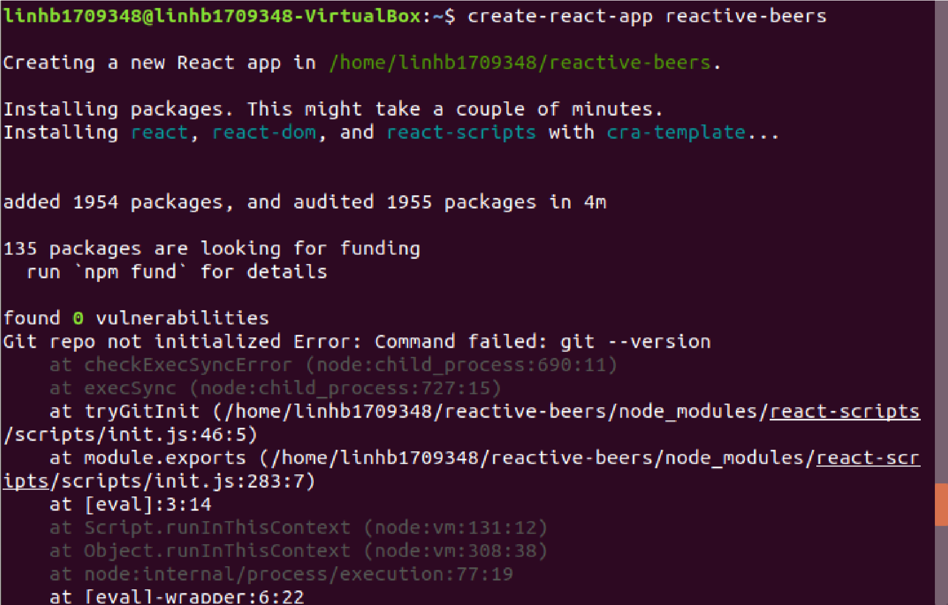

***Note: Nếu bị lỗi cài đặt ở bước này

([[https://github.com/facebook/create-react-app/issues/6776](https://github.com/facebook/create-react-app/issues/6776)])

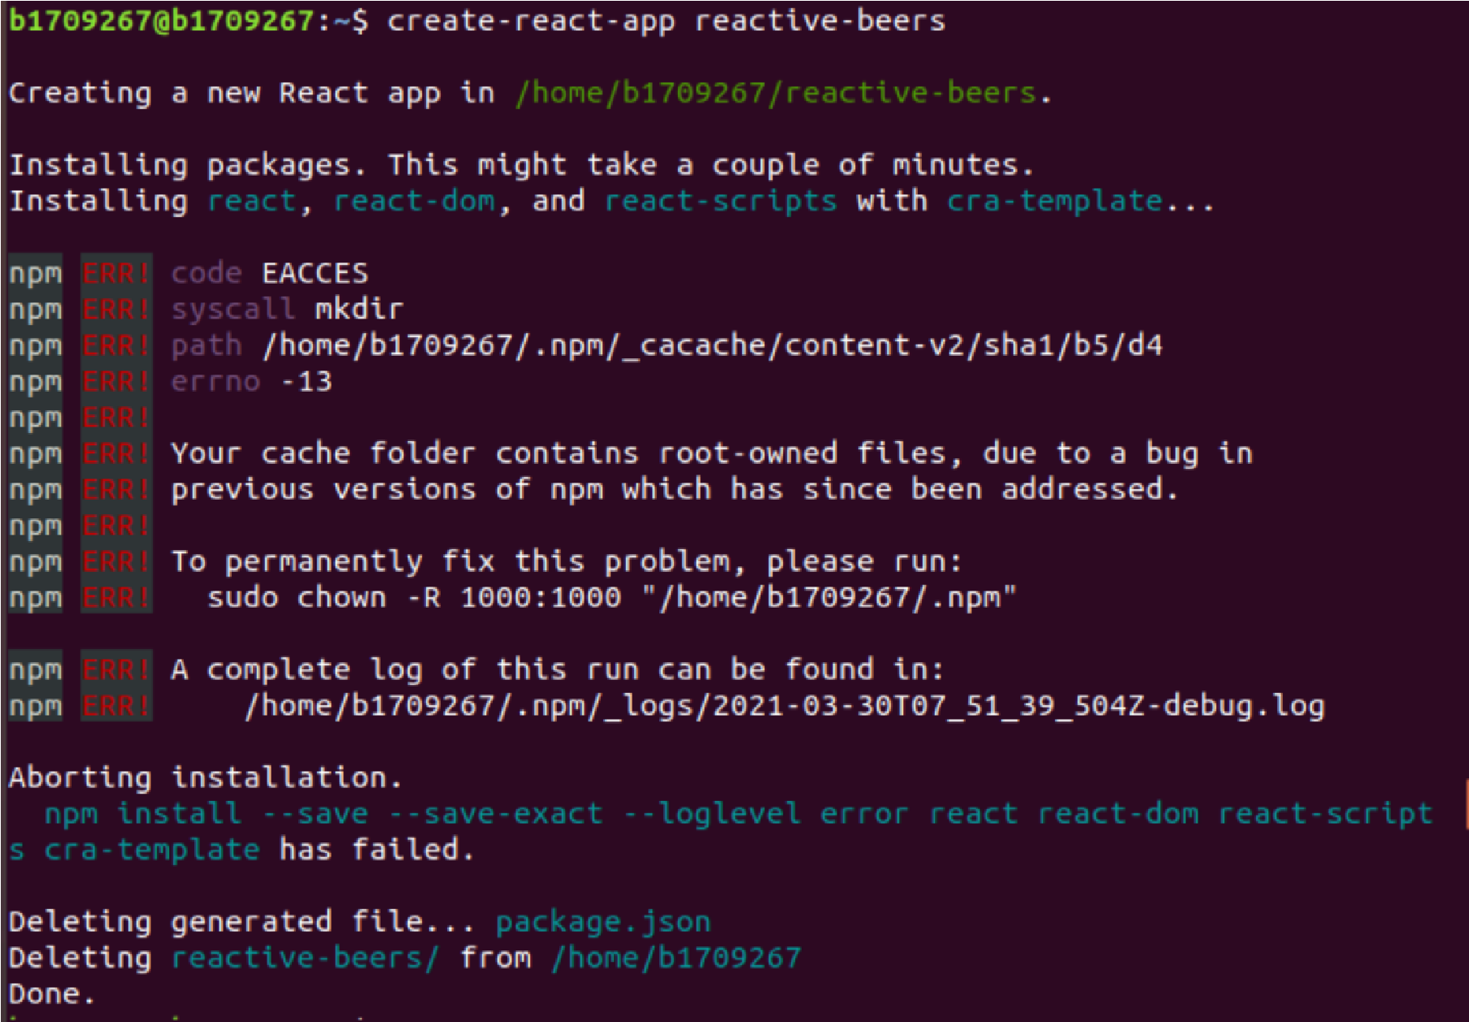

Hãy gõ lệnh “sudo npm cache clean --force”:



K

ế

t

q

u

ả

:

C

h

u

y

ể

n

v

à

o

t

h

ư

m

ụ

c

R

e

a

c

t

i

v

e

-

b

e

e

r

s

v

à

c

à

i

đ

ặ

t

P

o

u

c

h

d

b

:

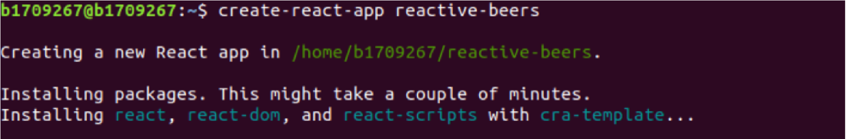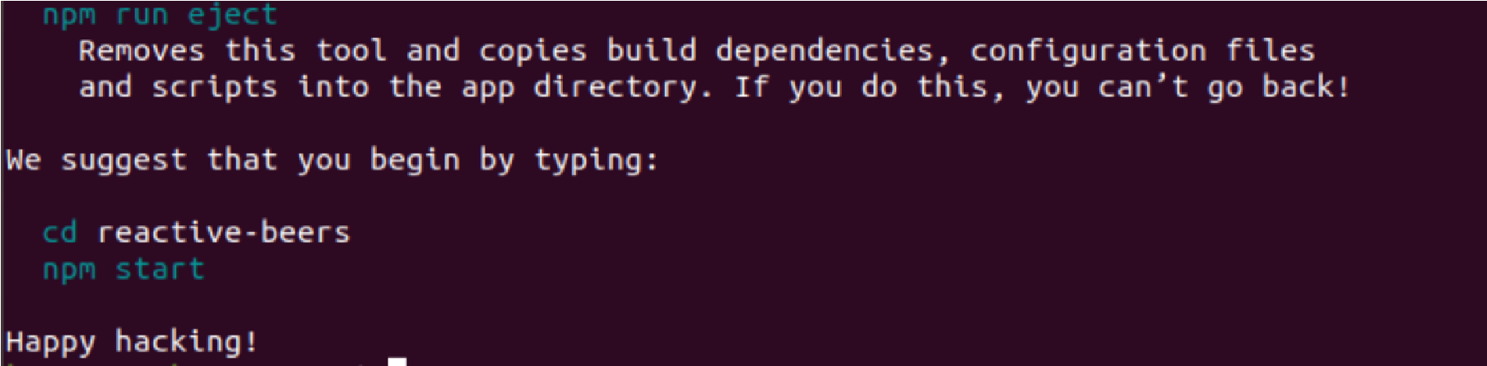

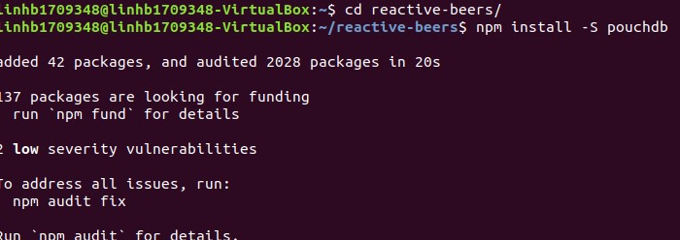

Cài đặt tree:

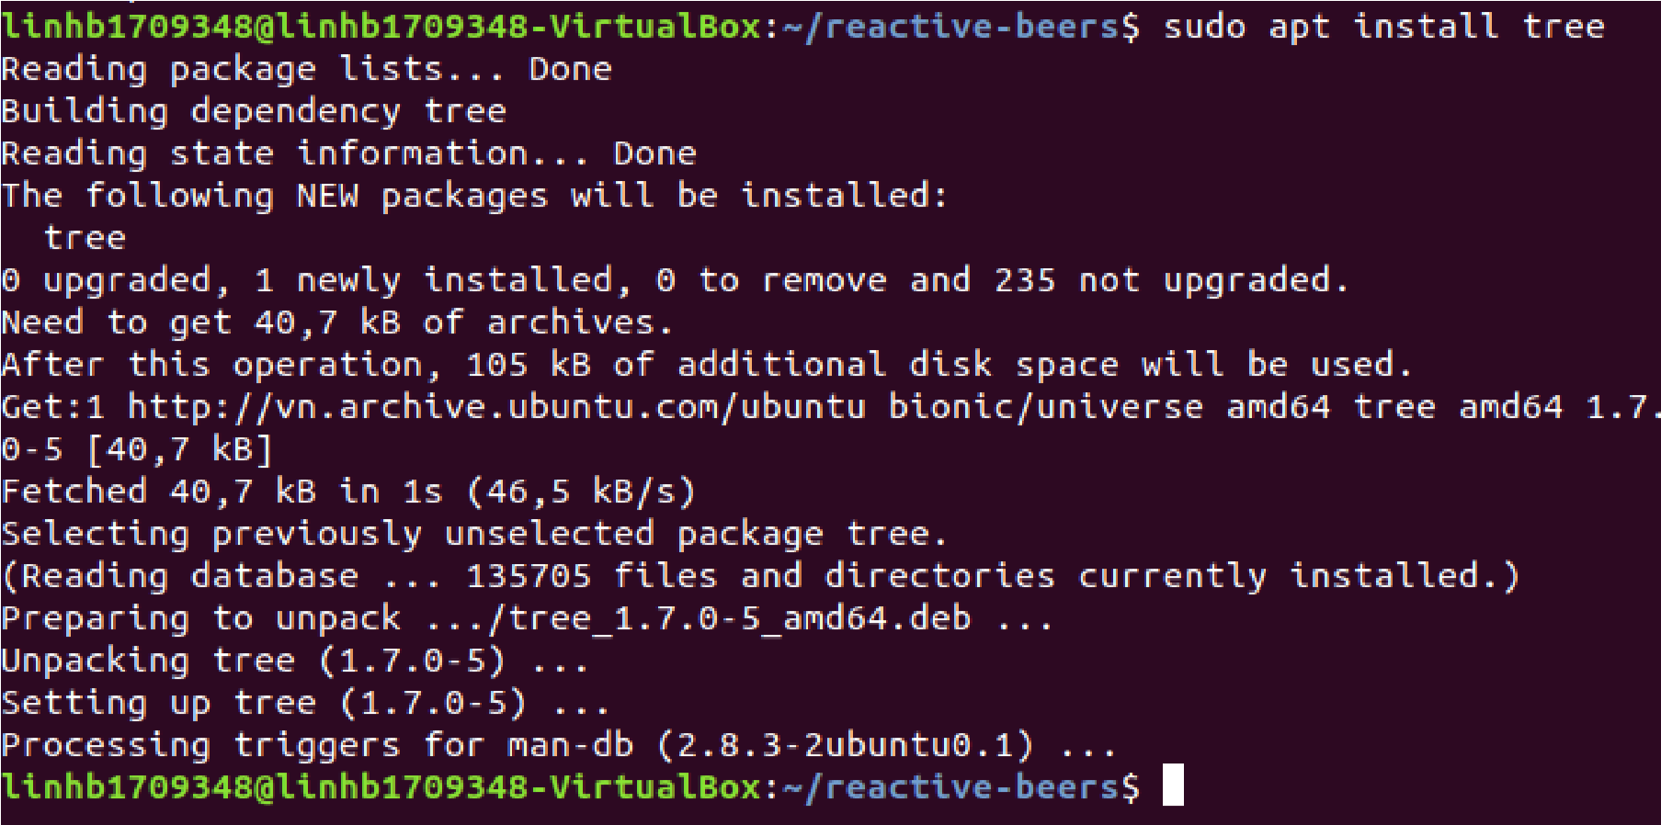

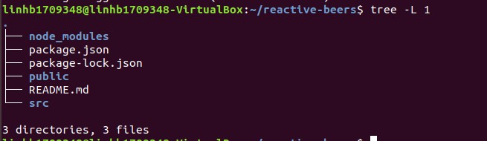

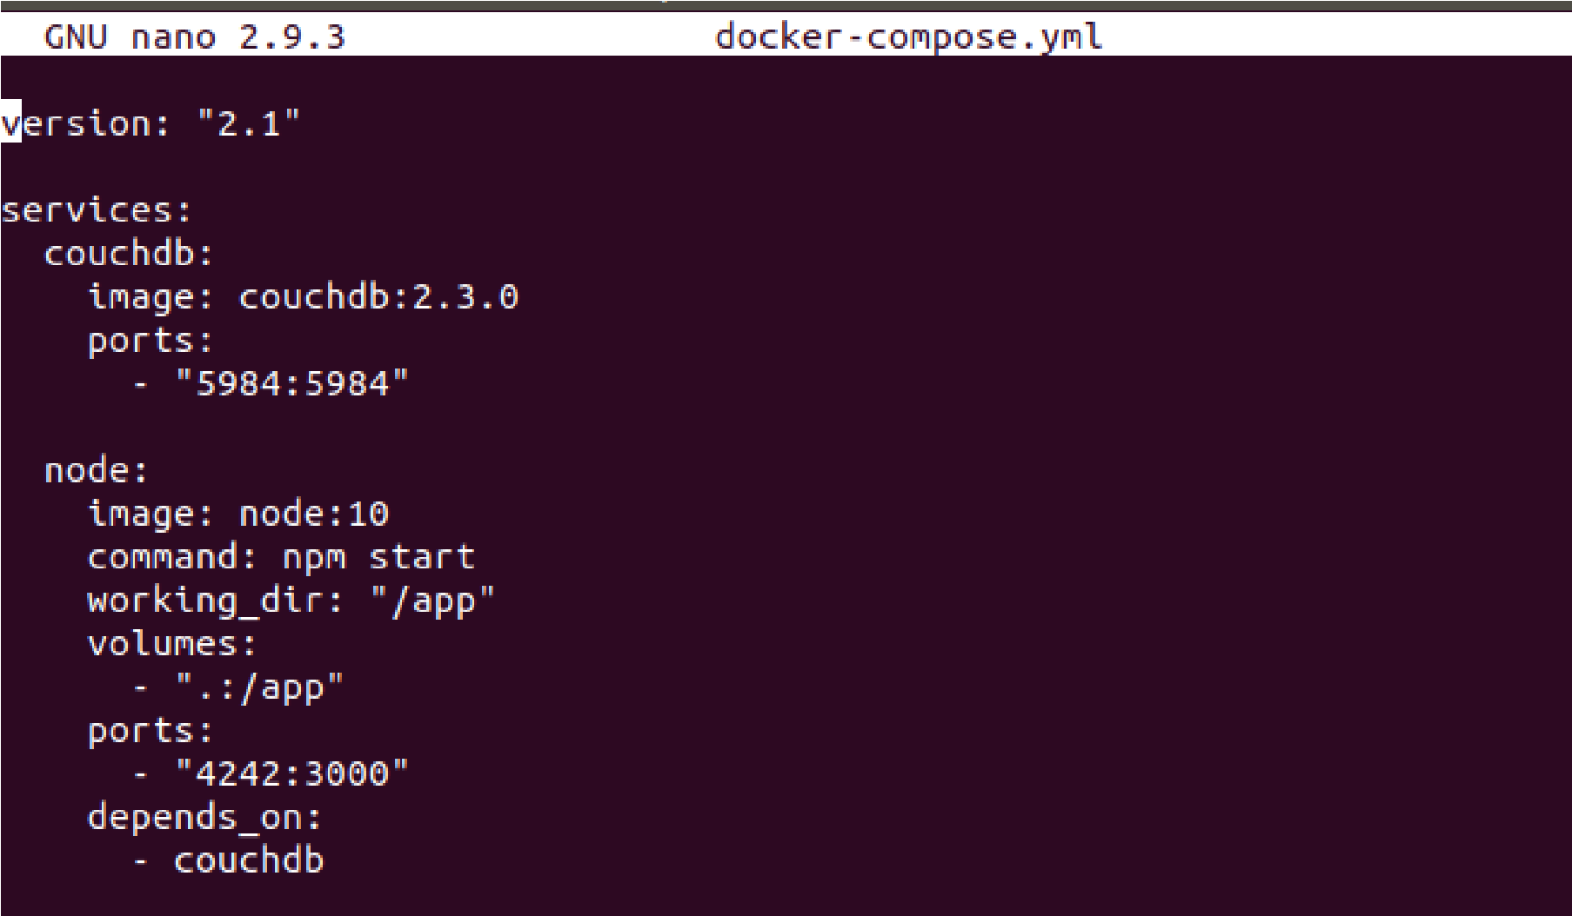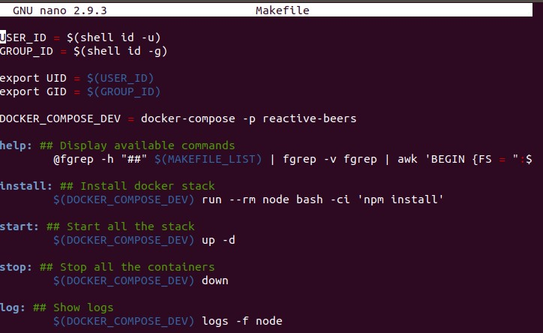

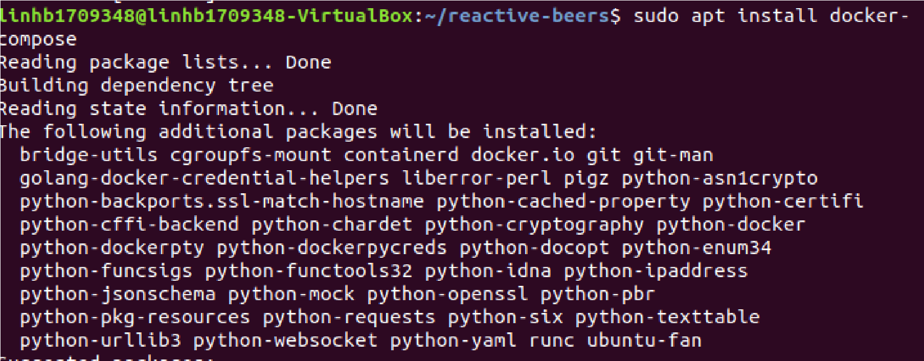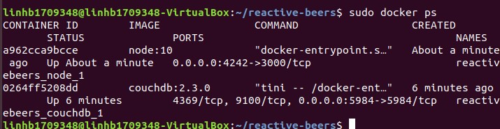

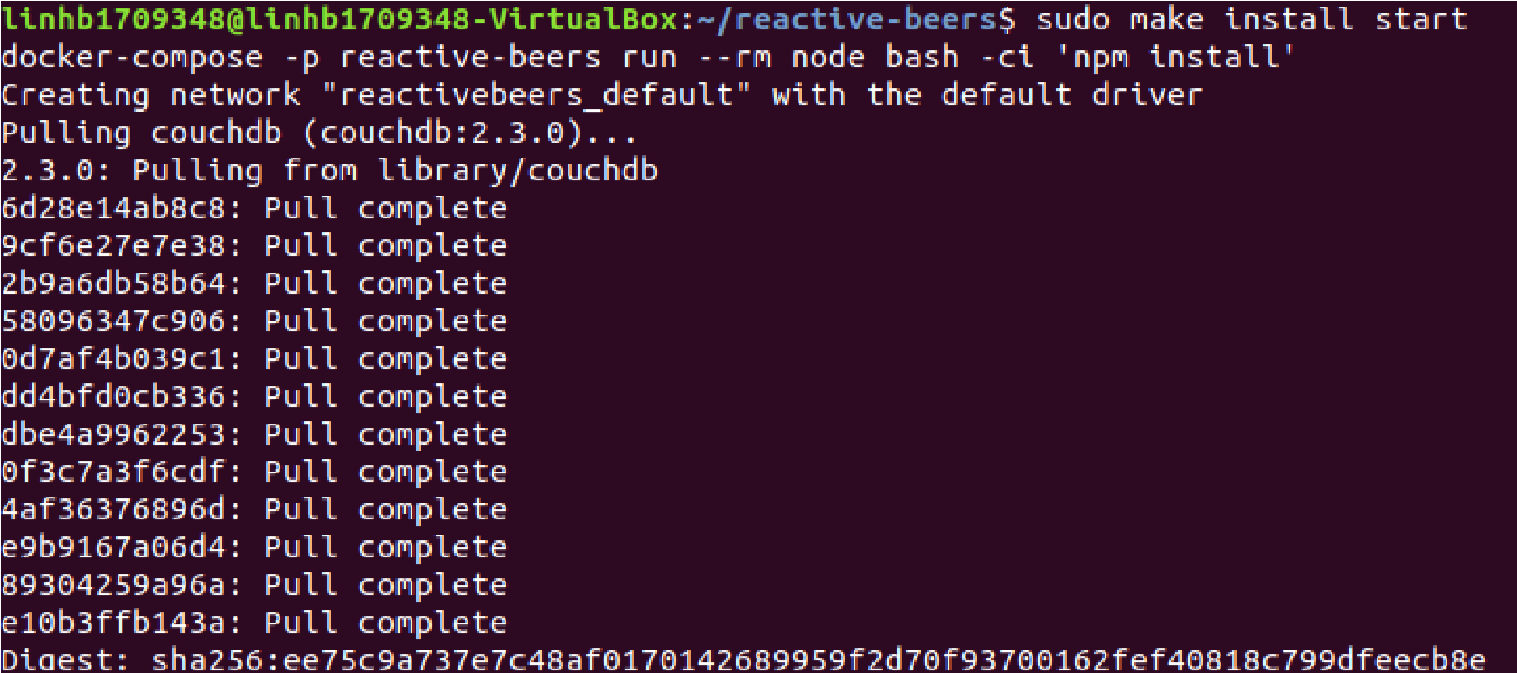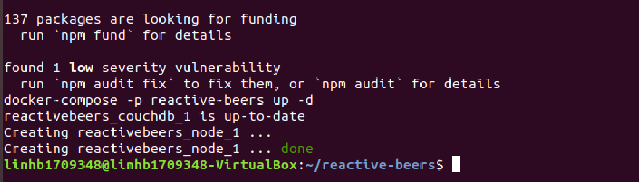

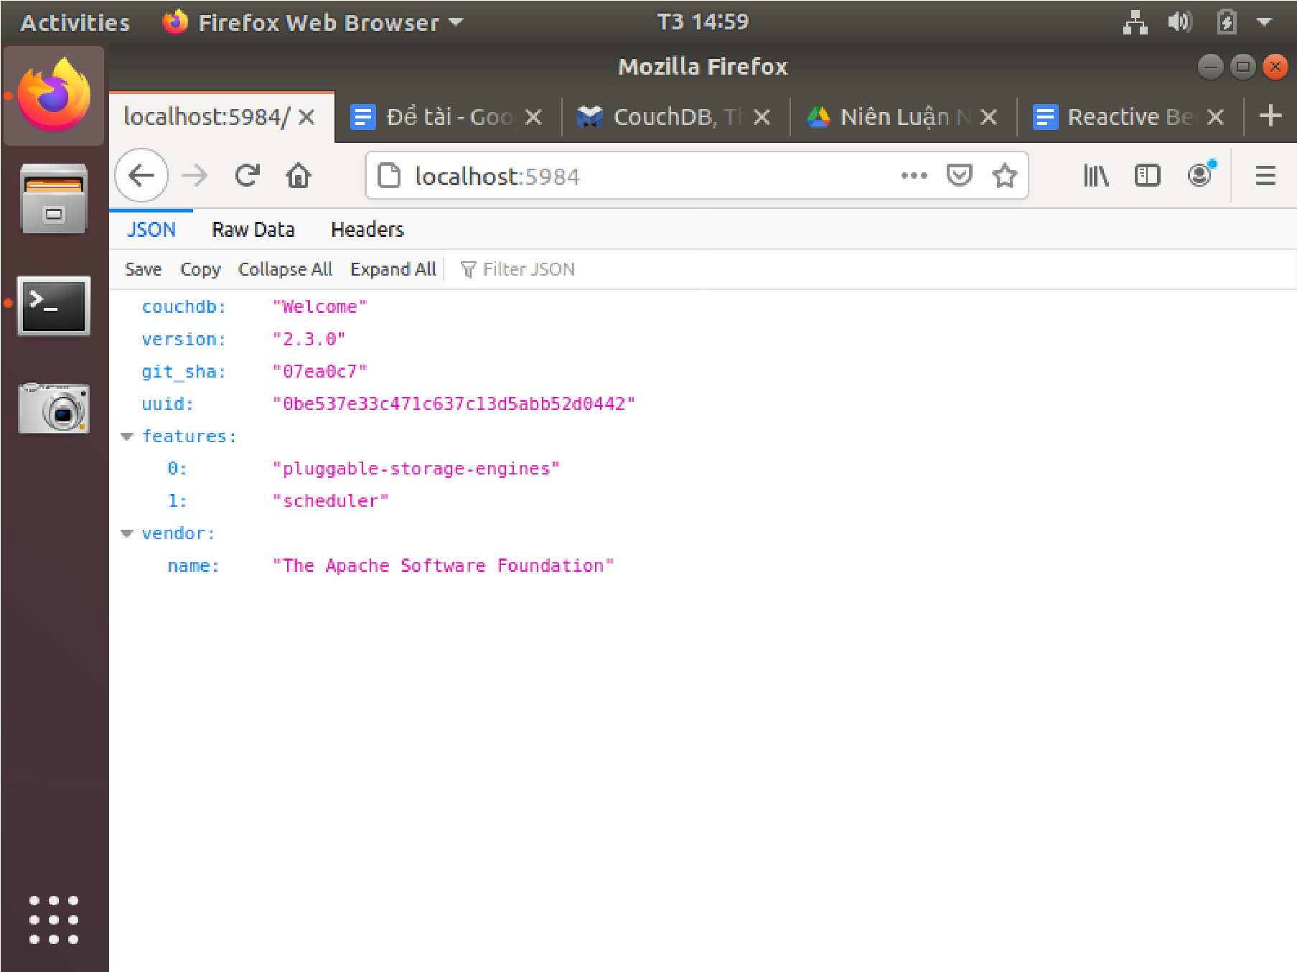

Nếu lỗi lệnh “sudo npm start”:

([[https://stackoverflow.com/questions/54751812/getting-enoent-no-such-file-or-directory-ope n-error-when-trying-to-move-app](https://stackoverflow.com/questions/54751812/getting-enoent-no-such-file-or-directory-open-error-when-trying-to-move-app)])

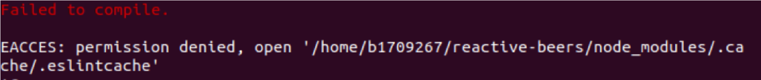

Hãy chạy lệnh “mv node_modules/.cache node_modules/.cacheBackup”



Sau đó chạy lại lệnh “sudo npm start”:

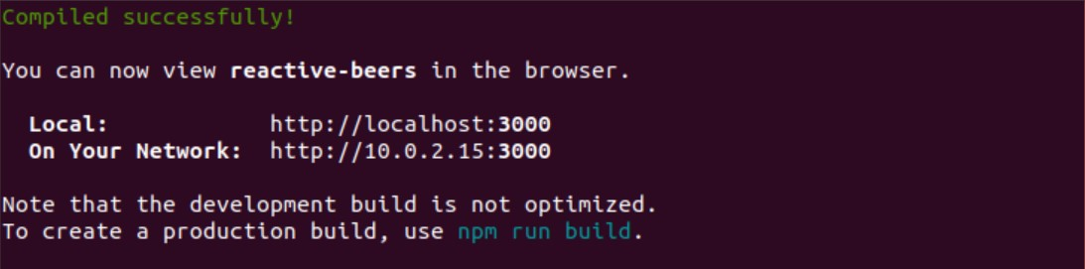

Nếu lệnh “sudo npm start” lỗi 1 lần nữa hay xóa file backup (node_modules/.cacheBackup) bằng lệnh rm. Sau đó chạy lệnh “mv node_modules/.cache node_modules/.cacheBackup” và chạy lại “sudo npm start”

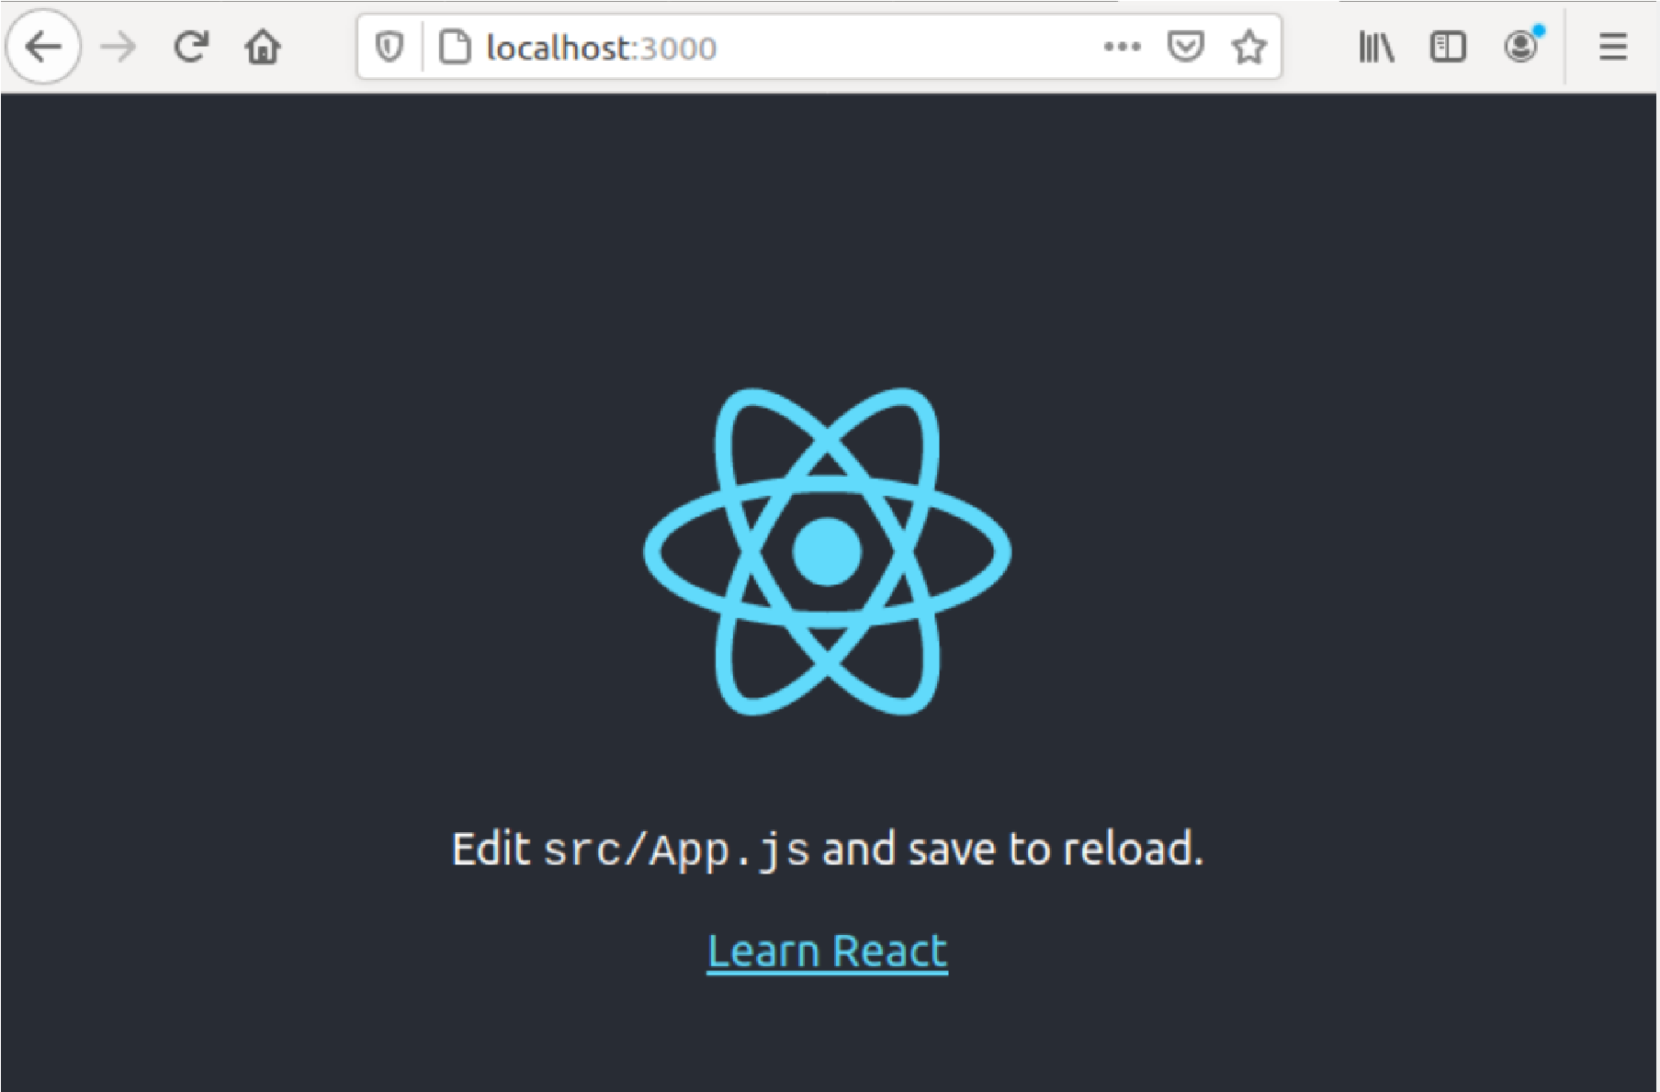

Database lúc này vẫn chưa có gì:

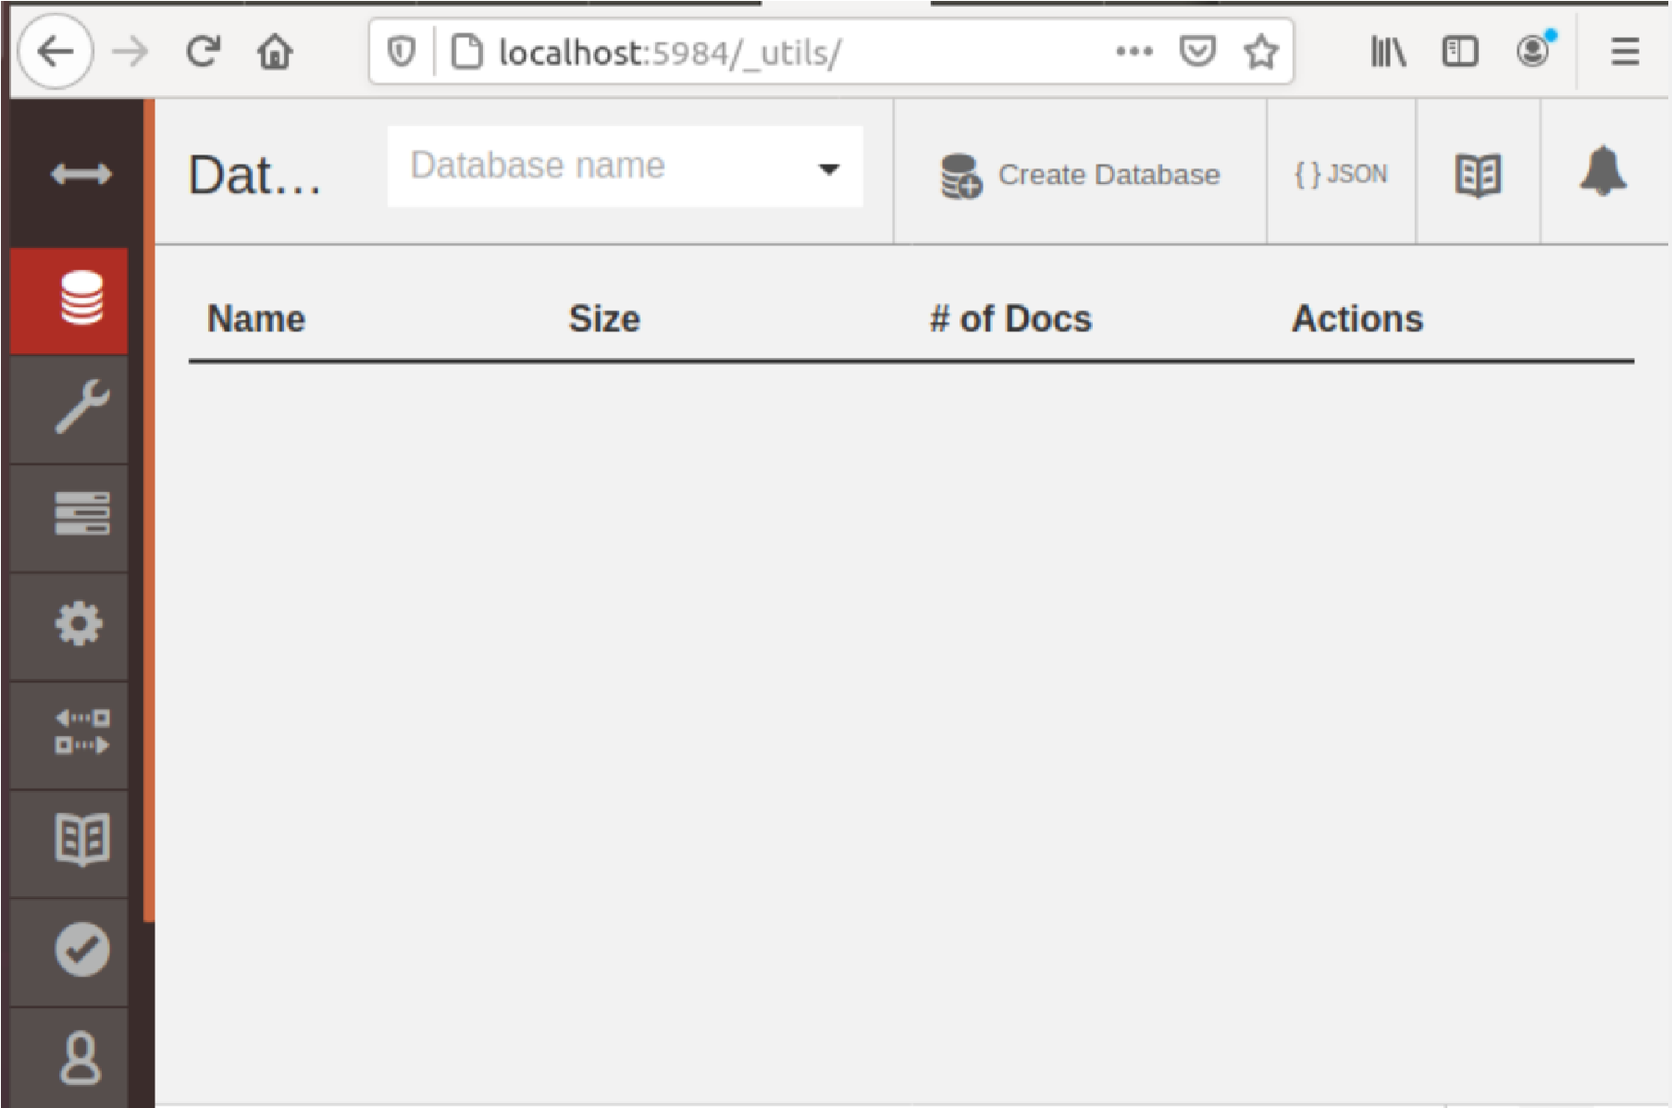

Tiến hành thiết lập cơ bản:

D

a

t

a

b

a

s

e

l

ú

c

n

à

y

:

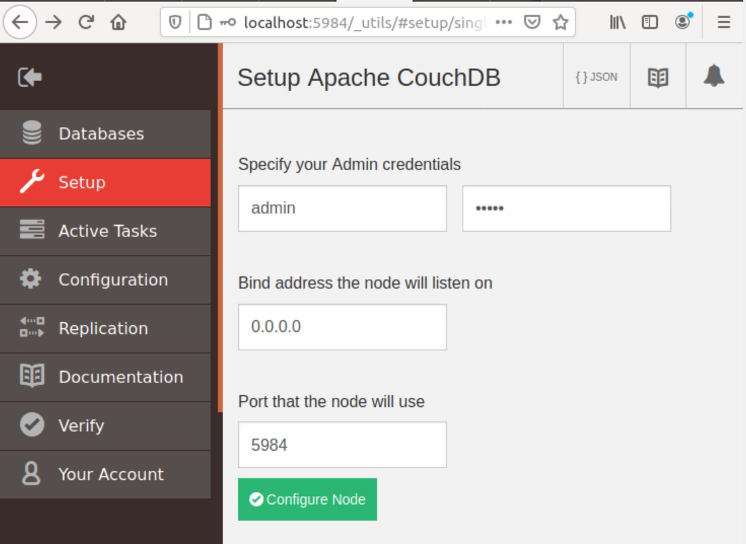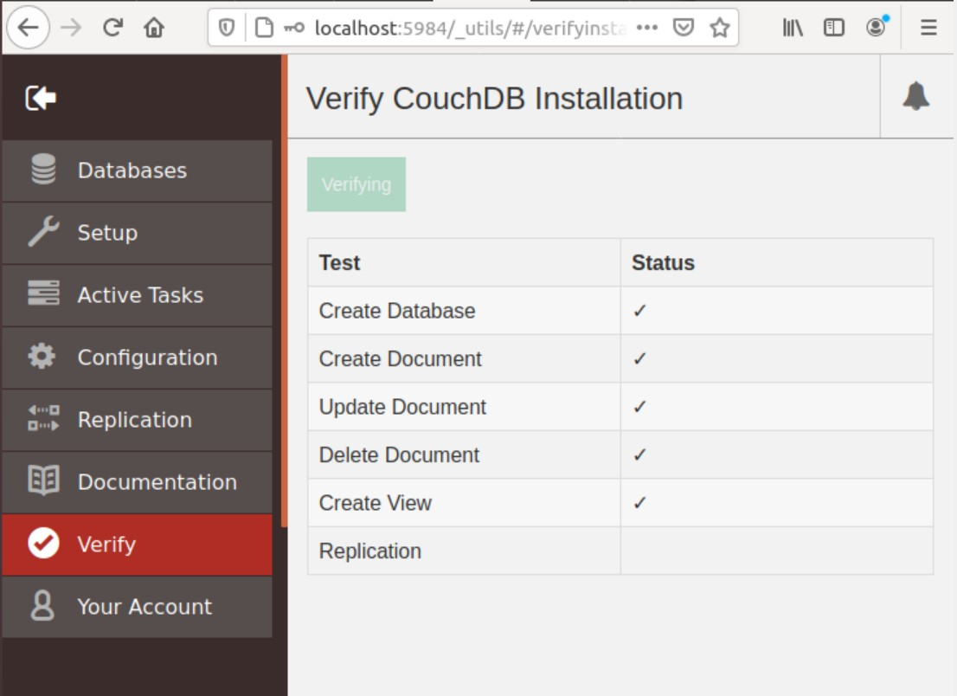

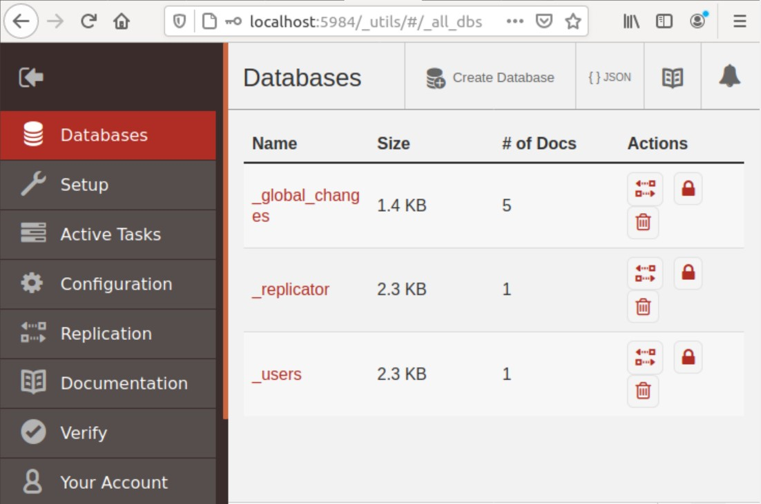

Nhập <http://localhost:3000> trên trình duyệt firefox:

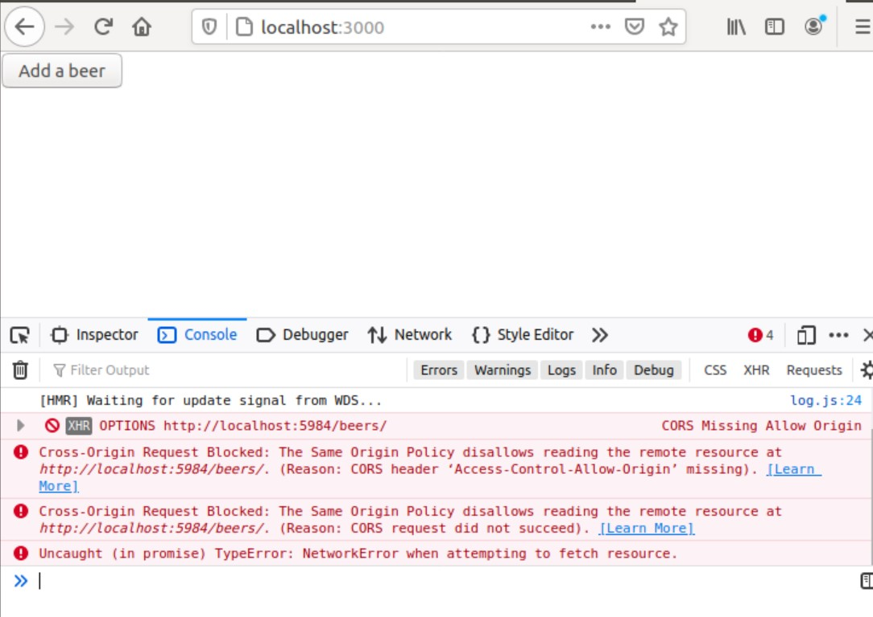

Thực hiện các bước sau để sửa lỗi: ([[https://pouchdb.com/errors.html](https://pouchdb.com/errors.html)])

Chạy lệnh sudo npm install -g add-cors-to-coucdb để cài đặt add-cors vào couchdb.

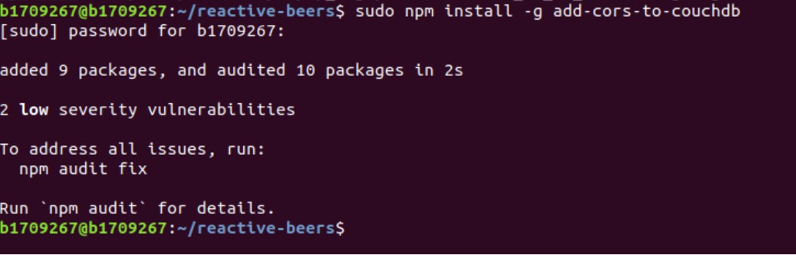

Sau khi cài xong ta dùng lệnh sudo add-cors-to-couchdb [http://127.0.0.1:5984/](https://172.0.0.1:5984/) -u myusername -p mypassword (myusername và và mypassword :tên user và password để đăng nhập vào couchdb đã tạo lúc ban đầu).

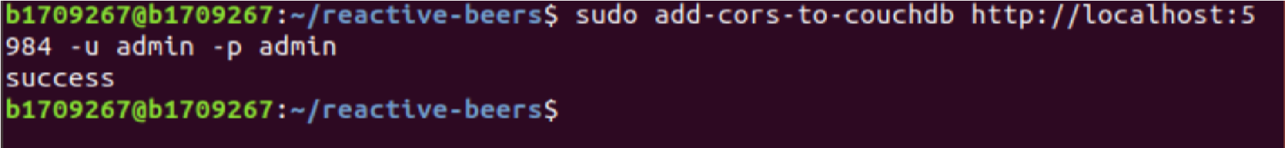

Tiếp theo chạy lệnh sudo npm start ta thu được kết quả như sau:

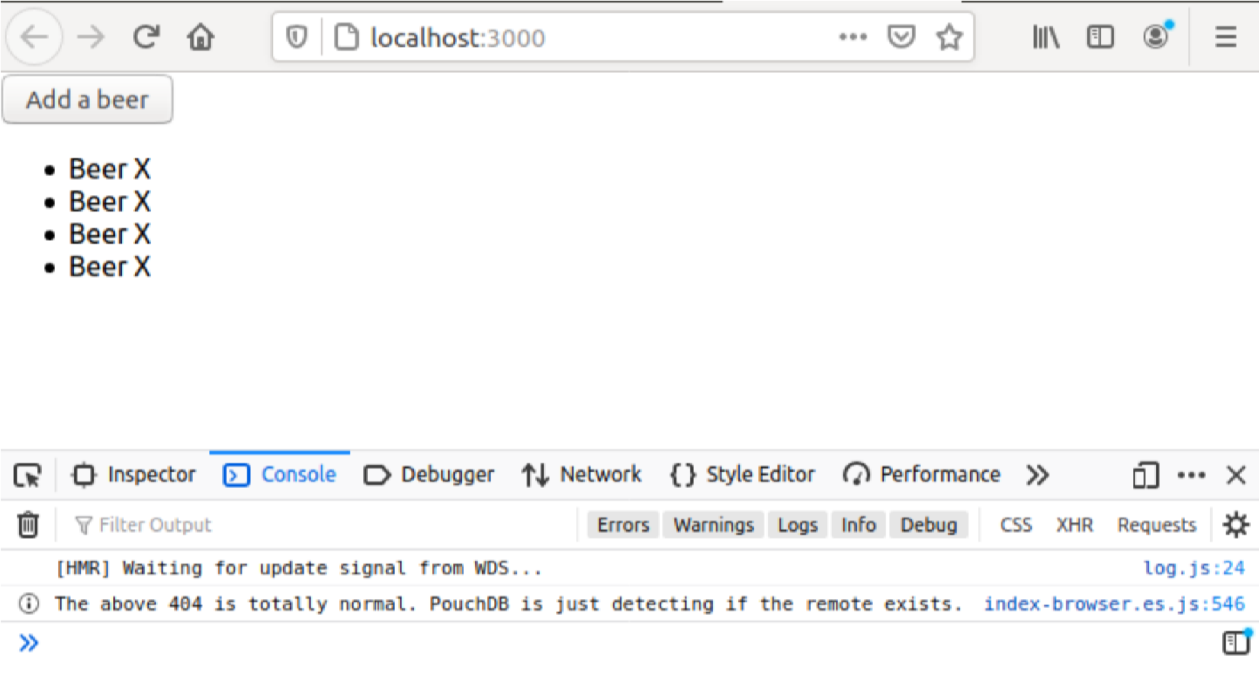

Lúc này nếu database beers chưa được tạo ra sẽ được tạo tự động:

